PUT Request

* localhost:3000/api/updatePostByID/1

<https://www.prisma.io/docs/orm/overview/prisma-in-your-stack/rest>

**REST API server example**

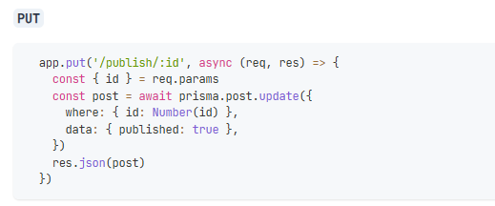

Server.js

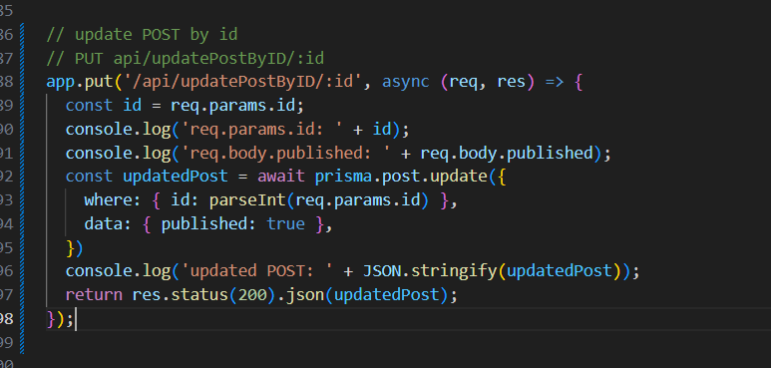

Server.js

import { PrismaClient } from '@prisma/client';

import express from 'express';

const app = express();

const prisma = new PrismaClient();

// update POST by id

// PUT api/updatePostByID/:id

app.put('/api/**updatePostByID**/:id', async (req, res) => {

  const id = req.params.id;

  console.log('req.params.id: ' + id);

  console.log('req.body.published: ' + req.body.published);

  const updatedPost = await prisma.post.update({

    where: { id: parseInt(req.params.id) },

    data: { published: true },

  })

  console.log('updated POST: ' + JSON.stringify(updatedPost));

  return res.status(200).json(updatedPost);

});

app.listen(3000, () => {

    console.log('Server is running at port 3000');

})

On package.json:

"dev": "nodemon --watch --exec node src/server.js",

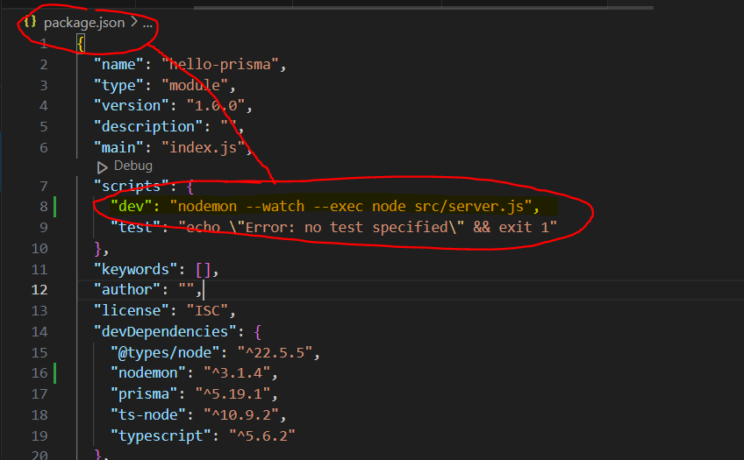

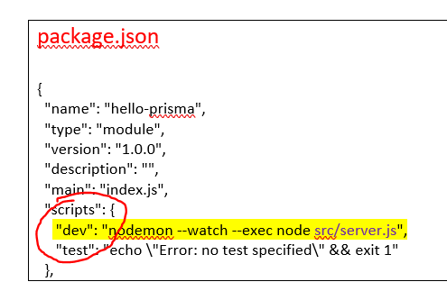

package.json

{

  "name": "hello-prisma",

  "type": "module",

  "version": "1.0.0",

  "description": "",

  "main": "index.js",

  "scripts": {

     "dev": "nodemon --watch --exec node src/server.js",

    "test": "echo \"Error: no test specified\" && exit 1"

  },

* RE-RUN SERVER…   
  (As long as change something in the server.js. We need to re-run the server.)
* Ctrl + C 🡪 Type 🡪 J 🡪 Stop the Server

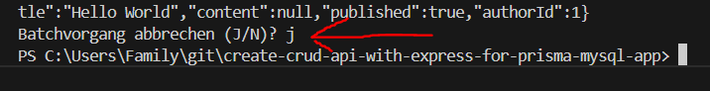

* RUN SERVER… | npm run dev

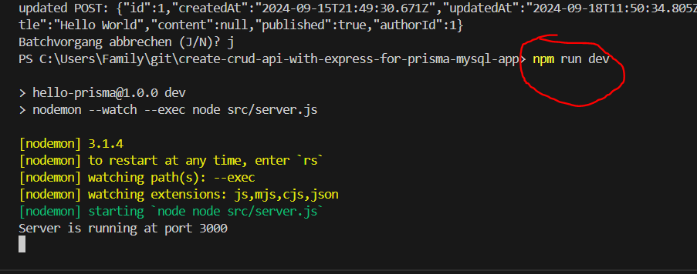

Thnder Client | http Client

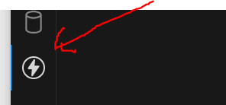

<https://www.prisma.io/docs/orm/overview/prisma-in-your-stack/rest>

**REST API server example**



**PUT 🡪 localhost:3000/api/updatePostByID/1**

**:id = 1**

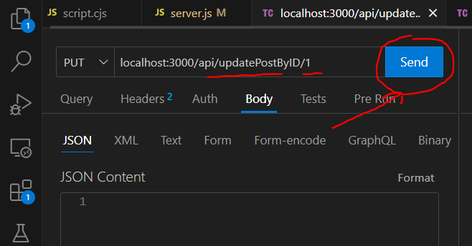

GET Response updated info with Status 200 OK 😊

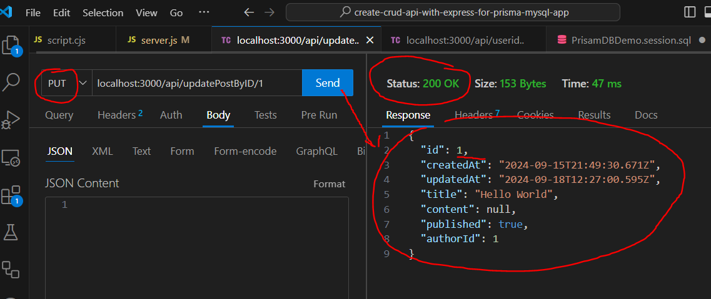

{

"id": 1,

"createdAt": "2024-09-15T21:49:30.671Z",

"updatedAt": "2024-09-18T12:27:00.595Z",

"title": "Hello World",

"content": null,

"published": true,

"authorId": 1

}

LOG 🡪

req.body.published: undefined is correct because we do not give any data in the PUT Request Body.

req.params.id: 1 is correct the id was given in the pararmeter localhost:3000/api/updatePostByID/1



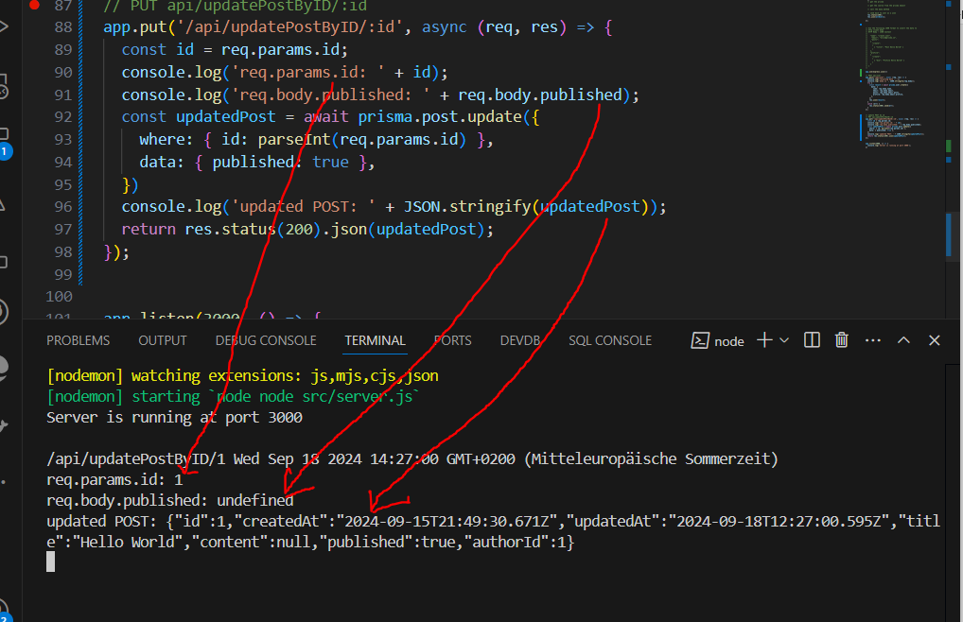

LOG OK 😊

MySQL database

LOG INFO

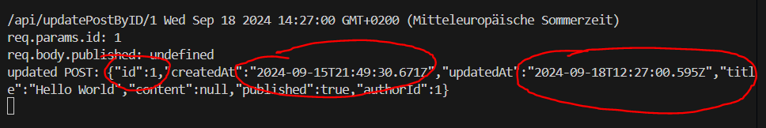

Database updated INFO 🡪 OK

